KXR-C110 Fully automatic box protection dispensing machine

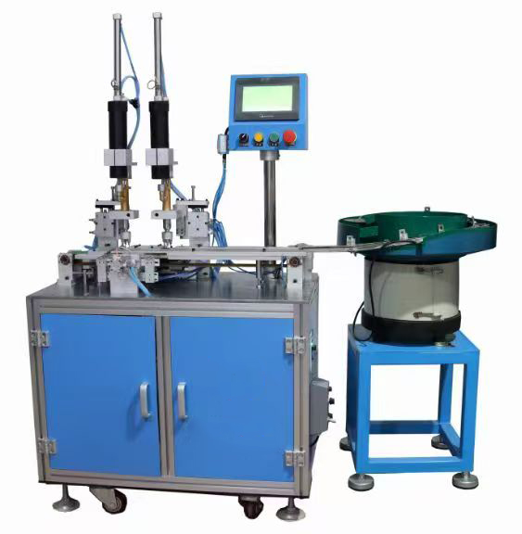

Technical Parameters:
Shell size range: 14-30mm
Air pressure requirement: 0.5-0.8MPa
Operating air source: AC220V 50Hz
Device dimensions: 1600*900*1400mm

Product Advantages:
Dual dispensing head design allows for simultaneous dispensing of two products, resulting in high production efficiency.
Precise dispensing position, uniform glue volume, and easy adjustment for format changes. Fully automated production effectively reduces production staff and saves costs.

Product Description:
1. Automatic dispensing machine equipped with a vibrating plate and two dispensing guns.
2. Dispenses two adhesive shells at a time, with three dots per shell, ensuring uniform glue application.
3. Dispensing speed: 50-60 pieces/minute (speed depends on product size and glue application volume. Larger products experience faster dispensing times, while smaller products experience slower dispensing times due to smaller needles).
4. Dispensing head size can be customized to meet customer requirements, suitable for high-viscosity adhesives such as silicone and silicone grease.

PRACTICAL APPLICATION :

Training for Customers on KXR-C110 Fully Automatic Box Protection Dispensing Machine Operation

1.All service engineers with 10 years of experience have received special technical training, including specialized expertise in the KXR-C110 Fully automatic box protection dispensing machine, enabling them to effectively handle various breakdown issues specific to this automated dispensing equipment.

2.We guide users to accurately operate and maintain the KXR-C110 Fully automatic box protection dispensing machine—with focused attention to its automated dispensing mechanisms, precision control systems, and box protection application processes—while providing free consultation about the production process technology of electronic products, particularly those involving protective dispensing applications.

3.To ensure the KXR-C110 Fully automatic box protection dispensing machine operates normally, we conduct dedicated training on its dispensing programming, operation procedures, usage, and maintenance through English manuals, model-specific instructional videos, and online guidance, tailored to the unique requirements of this fully automatic box protection dispensing equipment.
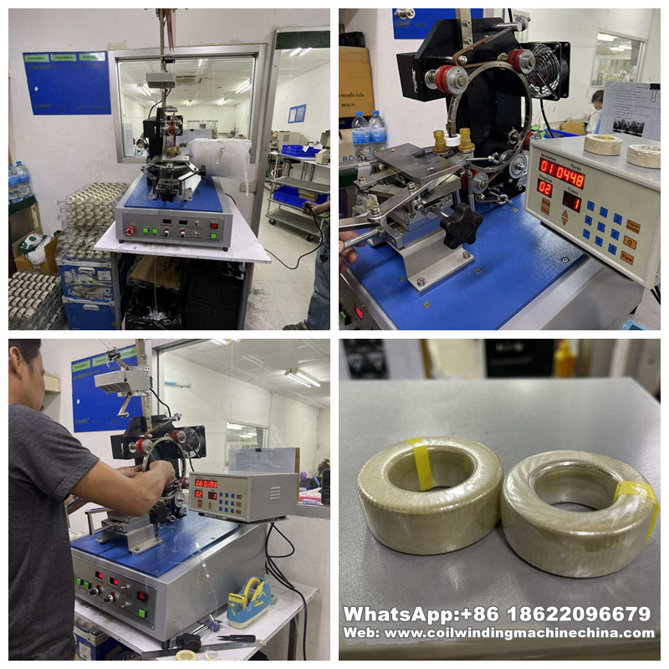

PACKAGING:

Packaging Material: Carton/Wooden case with foam inside.
1.General package(Paper carton or plastic bag): For small euipped parts for Hook Type Transformer Winding Machine, Package it with form and pack paper to guarantee unbroken during the transport.
2.Wooden case package: For larger scale Hook Type Transformer Winding Machine,we have special skilled carpenter, who would make the proper wooden case with exact thickness,density,length. The up arrow ↑marked on the outer wooden case. Buffer material would be put in the wooden case to prevent crack and shock.

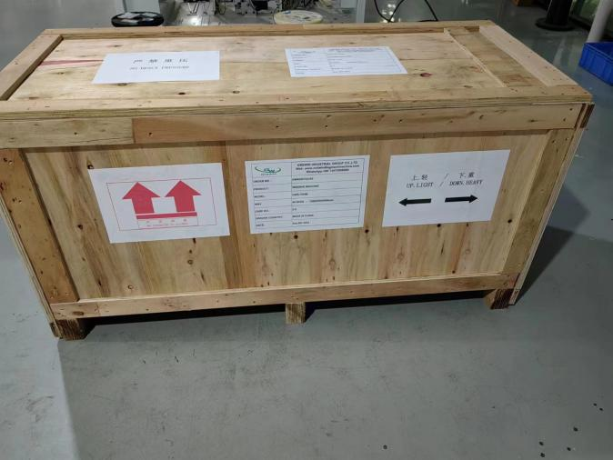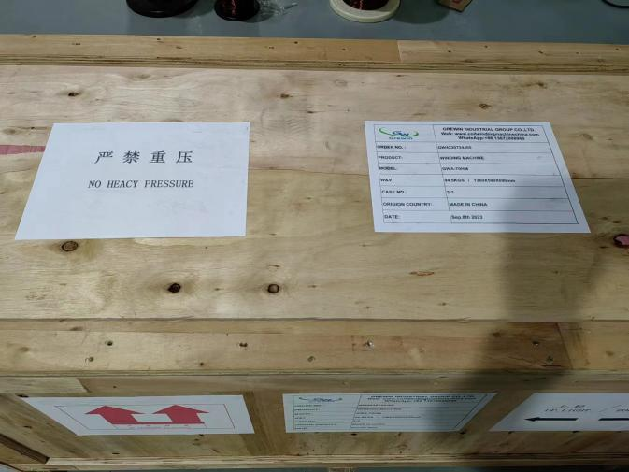

FACTORY:
We, KIOXIA LIGHT RING EQUIPMENT GROUP CO.,LTD., have been experts in winding machine lines for 28 years, with our diversified product portfolio extending to specialized automation equipment like the KXR-C110 Fully automatic box protection dispensing machine—a cutting-edge solution engineered for precise, automated dispensing in box protection applications, complementing our core winding technology expertise with advanced protective processing capabilities.

Our KIOXIA LIGHT RING brand holds authoritative certifications and recognitions, including ISO9001:2015, CE approvals, multiple machine patents (encompassing key innovations in models like the KXR-C110 Fully automatic box protection dispensing machine), and the official designation of "high-tech enterprise" by the government. These credentials fully validate the reliability, precision, and technical excellence of our entire product range, reinforcing our commitment to delivering comprehensive manufacturing solutions for diverse electronic component production needs.
